**HTML 5 Assignment**

**PRAJAPATI PAVAN**

1. What are the new tags added in HTML5?

* The following tags are added in HTML5.
* <audio> : This tag is use to add audio file on a web page.
* <video> : This tag is use to add video file on a web page.
* <canvas>: This tag is use to draw graphics on HTML web page.
* <mark> : This tag is use to mark the text on HTML web page.

1. How to embed audio and video in a webpage?

* The <audio> tag is use to embed audio on a web page.

Example:

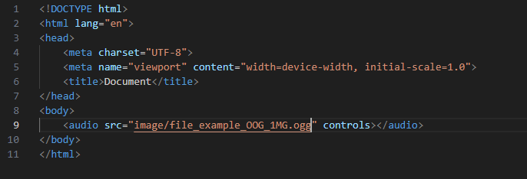

* The <video> tag is use to embed video on a HTML web page.

Example:

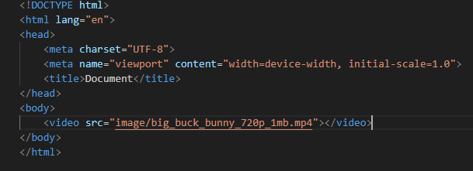

1. Semantic element in HTML5?

* Semantic elements in HTML5 are as follows.
* <section>: The section element use to define a section in a document
* <article>:The <article> element specifies independent, self-contained content.
* <header>: The <header> element represent a set of navigational links.
* <footer>: The <footer> element is use to define a footer on a web page.
* <nav>: The <nav> element is use to define a set of navigation links.

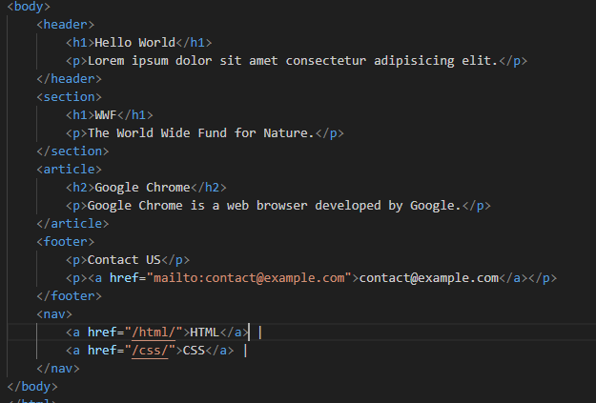

Output:

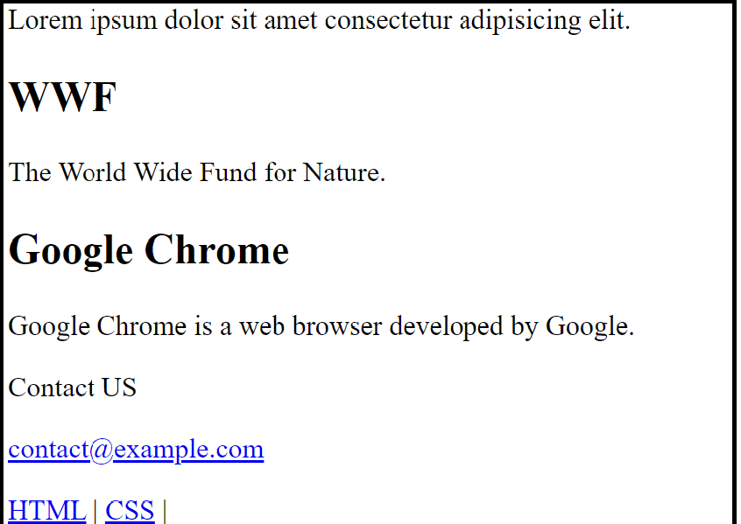

1. Canvas and SVG tags,

* **Canvas :** The HTML <canvas> element is used to draw a graphics on a web page.

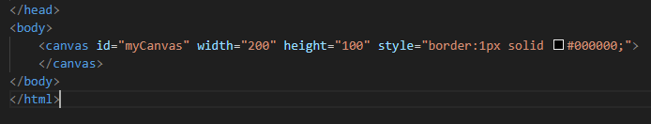

**Output:**



**SVG**:

* SVG stands for Scalable Vector Graphics.
* SVG is used to define graphics for the Web.
* The <svg> element id use to define a graphic on a web page.

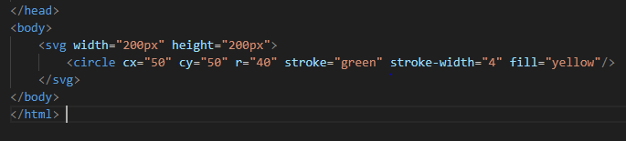

Output:

